- CNN vs ResNet Performance
Both the CNN and ResNet model achieved accuracy of 70% on the test set.
METRIC | CNN | ResNet
Accuracy | 70% | 70%
Precision(0) | 0 | 0
Recall (0) | 0 | 0
Precision(1) | 0.70 | 0.70
Recall(1) | 1.00 | 1.00

For both CNN and ResNet-
 | Precision | Recall | F1-score | Support
0 | 0 | 0 | 0 | 3
1 | 0.70 | 1.00 | 0.82 | 7
Accuracy |  |  | 0.70 | 10

Confusion matrix for both-
[[0,3],
[0.7]]
Both models predicted only the major class and no prediction was made for the smaller class. This problem has risen due to the use of a smaller dataset which results in class imbalance and not due to a problem in the learning model.
While CNN was built from scratch ResNet was already pretrained on ImageNet but it’s advantages could not be highlighted due to usage of a small ISIC image dataset although ResNet should have given a better result.

- Observations from Patch based analysis
The patch based analysis divided the images into 32 x 32 patches to check how Visual Trasnformers process the data. Each patch captures the texture information independently and locally thus proving its superior accuracy.
It also demonstrated why transformers require large datasets,positional encodings and self-attention layers.
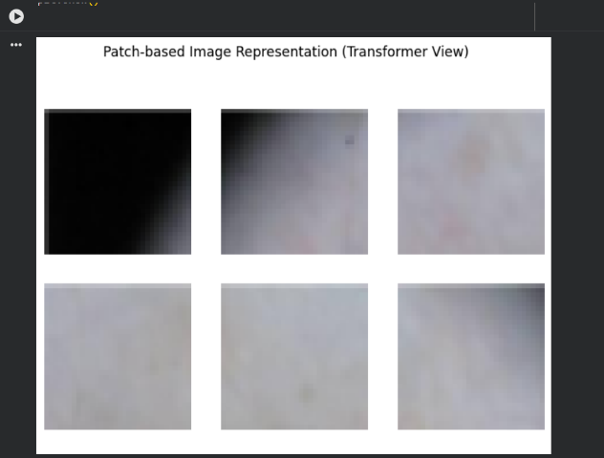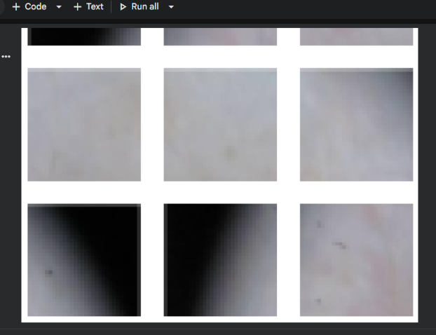

- Architectural Differences
CNN network is built in a way such that it consists of convolutional and fully developed layers and each layer receives input from only the previous layer. This model works well for small networks but pose a problem in the training of deeper datasets as layers stop learning effectively.

ResNet consists of skip layers which allow an input of earlier layer to be directly added to a later layer. These connections allow to even train deep network due to by easy gradient flow during backpropagation.

In my project, although ResNet has a superior architecture, both showed similar results due to the presence of a small and non-balanced dataset. But for larger datasets ResNet is going to be far more superior.

